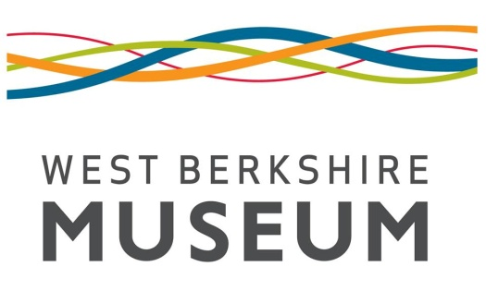
Notification of Fieldwork
West Berkshire Museum
The Wharf, Newbury, RG14 5AS
Tel 01635 30511
museum@westberks.gov.uk
www.westberkshireheritage.org/west-berkshire-museum
Depositor Name: | Site Name:
Address: | Site Address:
Site Manager/Main Contact: | Parish:
Tel: | Site Code:
Email: | Grid Reference:
Planning Reference Number: | OASIS Record ID:

Start Date: | Expected Deposition Date:

Type of Fieldwork: (please delete) | Evaluation / trenching / watching brief / field walking / excavation / survey / building recording
Type of site expected: (please delete) | Prehistoric / Roman / Medieval / Post-Medieval / Modern
Quantity of boxes expected: (please delete)  Paper Archive: 1 / 2-5 / >5  Finds Archive: <5 / 5-20 / >20 | Waterlogged material anticipated? Y/N  Conservation problems anticipated? Y/N

NOTIFICATION ACKNOWLEDGMENT
TO BE COMPLETED BY MUSEUM ON NOTIFICATION
Contract forwarded? Y/N | Signed Contract Returned: Y/N
Museum Accession Number: NEBYM:
Charge:
Invoice Number: | Date
Payment must be confirmed through our Accounts Department before processing of Deposit

ARCHIVE INFORMATION
TO BE COMPLETED BY WEST BERKSHIRE HERITAGE & DEPOSITOR PRIOR TO DEPOSIT
Number of Paper Archive Boxes: | Itemised Box List? Y/N
Number of Finds Boxes: | ToT for Paper Archive? Y/N
Number of Stewart Boxes: | ToT for Finds Archive/Landowner Consent Letter? Y/N/NA
Number of Plan Rolls: | Digital Archive Included? Y/N
Number of Unboxed Finds: | Security Copy Included? Y/N
Signed for Depositor: | Date:

DEPOSIT DETAILS
TO BE COMPLETED BY WEST BERKSHIRE HERITAGE
Archive Received in Satisfactory State: Y/N
Archaeology Notified: Y/N
Signed for Museum: | Date:
Archaeology Event Record Number: EWB
Signed for Archaeology: | Date:

